CSR/L-G01系列精小智能型电动执行机构
CSR/L-G01-series Teeny Smart Electric Actuator
操作手册Operating Instructions

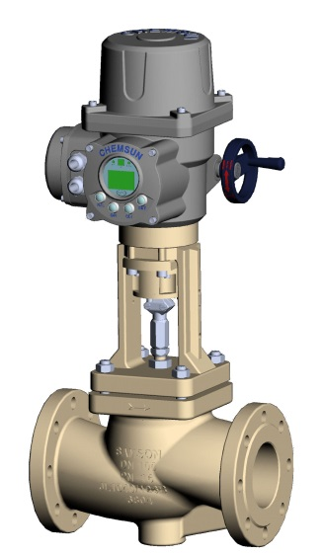
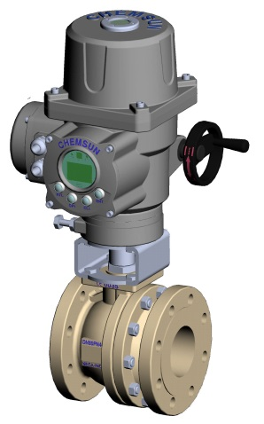

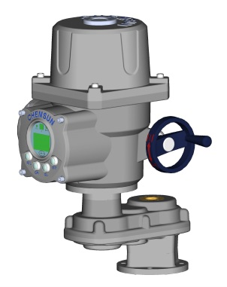

调试和使用该设备前敬请仔细阅读本手册！
Read the instructions carefully before commissioning & operating this device, please

北京凯姆斯智控科技有限公司
地址：北京市大兴区团河路9号行宫别墅第19号
电话：+（86）10 61277625
传真：+（86）10 87582920
网址：www.chemsun.com
邮箱：sales@chemsun.com

CHEMSUN EUROPE GMBH
Add: C/O Globe Office Center
Bettinastr.30 60325 Frankfurt / Main
Fon: +49(0) 69 1338 5311 Fax: +49(0) 69 1338 5312
URL: www.chemsun.de
Email: sales@chemsun.de

本手册适用于CHEMSUN CSR/L-G01型智能电动执行机构的安装、调试、使用和维护指导。
The operation manual is applicable to the installation, commissioning, usage and maintenance instruction of the CSR/L-G01 series intelligent electric actuator of the CHEMSUN.
警告：调试过程中进行全开/全关位置设置时，在接近阀门的全开或全关位置时，应该为手轮操作，严禁使用点动按钮进行点动操作，否则可能由于位置走过引起阀门或者执行机构的损坏，由于此种原因造成执行机构损坏，CHEMSUN 概不负责。
Warning: During the commissioning process, please change to handwheel operation mode when it is near the open or closed position of the valve; it is forbidden to operate by inching button; otherwise, the valve or actuator may be damaged by passing the position. CHEMSUN will not bear any responsibilities for such damage.
警告：在安装、调试、使用和维护CHEMSUN G01型智能电动执行机构前，必须仔细阅读本手册，严格按照安全操作规程操作，以防造成人身安全事故。
Warning: Please carefully read the operation manual before installation, commissioning, usage and maintenance of CHEMSUN G01-type intelligent electric actuator; operate in strict accordance with the safe operation regulations to prevent personal safety accident.
警告：在操作过程中，必须小心高温、高压、易燃、易爆、有毒及腐蚀性介质和高电压、强大外力等危险情况。
Warning: In the normal operation, please pay special attention to such dangers: high-temperature and high-pressure, combustible, explosive, poisonous and corrosive medium, high voltage and strong external force, etc..

目 录
Directory
使用安全/Safety of Usage 1
1 存放/Storage 4
2 执行机构的基本操作/Basic Operation of Actuator 6
2.1 手轮的操作/Handwheel Operation 6
2.2 电动操作/Electric Operation 7
2.2.1 组态按钮/ Function Button 8
2.2.2 手动（就地）/自动（远程）/Local/Remote Operation 9
2.3 手动/自动显示/Local Remote Display 9
2.4 实时状态显示/Display of Real-time Status 10
2.5 控制状态显示/Display of Control Status 10
2.6 信号报警显示/Display of Alarm 10
3 执行机构的安装/Installation of actuator 11
3.1 直行程联接/Linear Connection 12
3.2 角行程联接/Part-turn Connection 13
3.3 电气联接/Electric Connection 14
3.4 高度集成CPU控制模块/High-integrated CPU Control Module 15
3.5 接线端子排/Wiring Terminal Block 16
3.5.1 接线端子定义/Definition of Wiring Terminal 17
3.6 接线原理图/Wiring Schematic Diagram 19
4 调试/Commissioning 20
4.1 设置程序简介/Instruction of Setup Procedure 20
4.1.1概述/Overview 20
4.1.2设置程序的基本框图/Basic Block Diagram of Setup Procedure 21
4.2进入执行机构的设置程序/Access Setup Procedure of Actuator 23
4.3基本设置 (Basic setting) 24
4.3.1手动校准. (Zero Menu Check) 25
4.3.2精度调整（Accuracy Adjust） 26
4.3.3信号故障动作（Signal Fault Action） 27
4.3.4最大转速设置/Maximm Running Speed Setting 28
4.3.5自动手动设置/Local Manual Control Setup 28
4.4高级设置(Advanced Setting) 29
4.4.1设置密码/Password Setting 30
4.4.2作用方向 (POSI_NEG_Effct) 30
4.4.3报警端口设置 /Alert_com choice 30
4.4.4断电故障动作/Power Failure Action 31
4.4.5断电延时/Power Failure Delay 31
4.4.6 PID系数设置/PID Parameter Setting 31
4.4.7力矩校准/ Torque Calibrate 31
4.4.8恢复初始设置/ Restore Default Setting 31
1 设备维护和保养/Maintenance and Servicing of Equipment 32
1.1设备维护周期/ Equipment Maintenance Cycle 32
1.2润滑/Lubrication 32
2 故障信息及处理一览表/List of Fault Information and Settlement 33

标准诊断功能可对控制系统、阀门和执行机构的状态进行诊断，并通过执行机构显示屏以文字形式来显示。
The standard diagnosis function is able to make diagnosis to the working status of control system, valve and actuator, and displayed in the actuator’s screen in form of character.
设定、报警及状态菜单的文字说明可以是英语(默认)和中文。
The textual specification of setup, alarm and status menu includes English (default) and Chinese version.

本手册提供如下指导：
The operation manual provides the following instructions:
- 手动/电动[就地/远程]操作
- Manual/electric [Local/remote] operation
- 执行机构的准备和安装
- Preparation and installation of actuator
- 执行机构基本设定
- Basic setup of actuator
- 执行机构组态设定
- Configuration setup of actuator
- 维护及故障排除。
- Maintenance and fault settlement
- 销售服务
- Sales service

使用安全/Safety of Usage
本手册是为能胜任的用户安装、操作、调试及检查CHEMSUN G01型执行机构而出版的。只有经过培训的、有经验的人员才可以对CHEMSUN执行机构进行安装、维护及维修，并且必须按照本手册及其它相关资料来进行。用户及其设备操作人员应根据当地相关的安全与健康条例规定来熟悉他们的职责。
The operation manual is published to meet the competent user’s installation, operation and commissioning demand of CHEMSUN G01-type actuator. Only well-trained and experienced personnel are able to execute installation, maintenance and repair of CHEMSUN actuator; it must strictly adhere to this operation manual and related specifications herein. The user and its equipment operator shall become familiar with their responsibilities according to local safety and health stipulations.
当G01型执行机构与其它设备共同使用时，应充分考虑有可能发生的情况。如需要CHEMSUN G01型执行机构安全使用的更多资料及相关指导，可根据需要提供。
When G01-type actuating mechanism is applied together with other equipment, adequate considerations shall be made to possible conditions; more documents and related instructions are provided if required for safe usage of CHEMSUN G01-type actuator.
这些执行机构的电气安装、维护及使用应按照本国相关的、适合现场安装以及设备安全使用的法律、法规来进行。
The electric installation, maintenance and usage of actuator are in accordance with the national related laws and stipulations applicable to on-site installation conditions and safe usage of the equipment.
机械安装应按照本手册中的概述，并依照相关标准来进行。如果执行机构铭牌上标称为防爆型，则该执行机构只可安装到分类的1区和21区、2区和22区(或1组、 2组的1级或2级)防爆区域。除非铭牌上标称可用于更低的燃点，否则执行机构不能安装到燃点低于135°C的防爆区域中，执行机构只可安装到与铭牌标称的可燃气体分组相符的防爆区域。
The mechanical installation should be in accordance with the overview clearly specified in the operation manual and in reference to relevant standards; if the nominal in the nameplate is explosion-proof mode, the actuator can be only installed in classified Zone 1 and Zone 21, Zone 2 and Zone 22 (or Level I or Level II of Group 1, Group 2); except that nominal in the nameplate is applicable to lower combustion point, it is forbidden to install actuator in the explosion-proof area with a combustion point of lower than 135℃; the actuator can only be installed in the explosion-proof area compatible with the combustible gas grouping clearly specified in the nominal in the nameplate.
执行机构的电气安装、维护和使用也应依照特殊防爆认证相关的实施规程来进行。
The electric installation, maintenance and usage of actuator should be in accordance with the execution regulations clearly specified in the special explosion-proof accreditation.
如果执行机构符合防爆区域认证的要求,则无需对其进行检查和维修。无论在任何情况下，都不得对执行机构进行任意改造，因为这将使已经获得的防爆认证无效。
If the actuator meets the accreditation requirements of explosion-proof area, there is no need to make inspection or maintenance; under any circumstance, it is forbidden to modify the actuator since it will make obtained explosion-proof accreditation become invalid.
在防爆区域内，禁止用任何带电导体接触执行机构，除非进行经特殊允许的工作，否则应切断电源，将执行机构卸下并移到非防爆区域进行维修或保养。
In the explosion-proof area, it is forbidden to contact the actuator with any charged conductor except for special permission; otherwise, the user shall cut off the power supply, dismantle the actuator and displace to the non-explosion-proof area for maintenance or servicing.
警告：电机温度在常规操作时，执行机构电机外壳表面温度可能超过60℃。如果执行机构设定为电机温度保护旁路，则其防爆认证无效，使用此设定有可能发生电气危险，用户应考虑使用必要的安全措施加以保证。
Warning: In the normal operation, the surface temperature of motor shell of actuator may exceed 60℃; if protective bypass is collocated for the motor temperature, the explosion-proof accreditation is invalid. The setup may lead to electric danger; the user shall consider necessary safety measures.
警告：G01型执行机构用于海拔2500m以下。
Warning: Sm- type actuator is available below an altitude of 2500m.

存放/Storage
如果执行机构不能立即安装到现场，则应将其保存在一个干燥的场所，直到准备接线。
If the actuator fails to be immediately installed to the fixed position, it shall be stored in a dry till ready for connection.
警告：禁止露天、潮湿、雨水和淹没的环境中存放，由此造成的后果，CHEMSUN 公司将不承担任何责任。
Warning: It is forbidden to store the actuator in open air, humid, rainy and sunken environment; CHEMSUN does not bear any responsibilities for such consequences.
如果执行机构已经安装到现场，但还没有接线，那么建议您将电缆入口的塑料塞子换成缠有聚四氟乙烯带的密封金属塞。
If the actuator is installed into a fixed position without electric connection, it is recommended to replace plastic plug at the cable inlet into sealed metal plug enwrapped with teflon tape.
在使用过程中，执行机构主体部分需与腐蚀性介质、高压电缆、高强度磁场隔离。
In the normal usage, the main part of actuator must be isolated from the influential environment such as corrosive medium, high-voltage cable and high-strength magnetic field.
如无意外，CHEMSUN执行机构的密封结构将会很好地保护内部的电气部件。
The sealing structure of CHEMSUN actuator is able to protect the internal electric components except for accidental conditions.
每一台CHEMSUN执行机构在出厂前均已经过全面检测，如果正确安装、调试和密封，则可提供多年的无故障运行。
Each CHEMSUN actuator has received integrated inspection before leaving the factory; correct installation, commissioning and usage will assure non-fault operation for years.
警告：由于执行机构外壳为铝制品结构，禁止外力冲击以免变形造成外部结构损伤和漏油进水。
Warning: Since the shell of actuator is made of aluminum structure, it is forbidden to impact by strong external force; otherwise, the external structure is deformed and results in oil leakage and water ingress.

执行机构的基本操作/Basic Operation of Actuator

手轮的操作/Handwheel Operation
手轮可提供除电动之外的就地手动操作及紧急事态下的特殊操作。CHEMSUN 电动执行机构采用的是行星齿轮传动结构，所以，无离合装置，无论处于就地/远程，手动/电动状态下皆可转动手轮，不会造成事故。
The handwheel is able to provide local manual operation beyond electric operation and other special operation under emergency. CHEMSUN electric actuator adopts the planetary gear transmission structure, which has no clutch device, so it is safe to rotate the handwheel regardless of the local/remote, or manual/electric state.

图 2-1手柄的折叠
Grawing 2-1 Handle Folding

警告：关于电动执行机构的操作，任何情况下不允许用扳手之类的附加工具旋转手轮来打开或关闭阀门，这样可能会导致阀门或者电动执行机构损坏。
Warning: Under any circumstance, it is forbidden to rotate the handwheel by other additional tools to open or close the valve, such as the wrench; otherwise, the valve or electric actuator may be damaged.

电动操作/Electric Operation
在电动操作之前，请检查电源电压，应与执行机构铭牌上的电压要求相符。
Before electric operation, please inspect and confirm the power voltage corresponding with voltage requirements clearly specified in the nameplate of actuator.
警告：如果没有进行初步检查, 不要进行电动操作。
Warning: It is forbidden to electric operation with no preliminary inspection.
警告：电气连接一定保证在断电状态下进行，连接之前一定要检查电源形式（电压和频率等）和电机参数是否与要求一致。
Warning: The electric connection must be executed in the power-off state; before connection the user must check the consistency of power form (voltage and frequency, etc.) with motor parameters.
警告：电气设备的安装和连接只能由具备相应资质的受过专业培训的电气工程师和他指导并授权的人员完成，并严格按照相应规范进行操作。
Warning: The qualified and well-trained electric engineer or authorized personnel are designated for the equipment installation and connection in strict accordance with the operation manual.

组态按钮/ Function Button
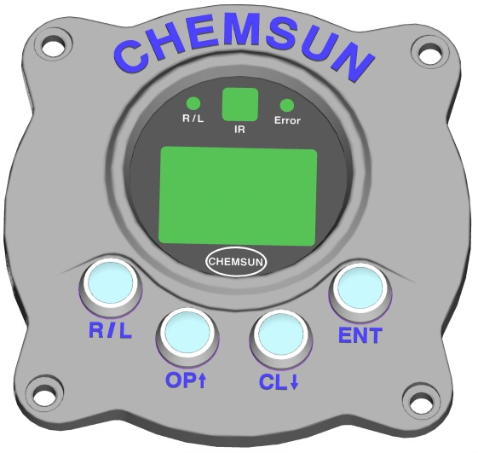

图 2-2 组态操作面板
Drawing 2-2 Configuration Operation Panel
“R/L”按钮：在设置过程中为“取消”键
“R/L” button: “Cancel” key in the setup
“ENT”按钮：在设置过程中为“确定”键
“ENT” button: “Confirm” key in the setup
“R/L”+“ENT”组合按钮：“就地/远程”切换键
“R/L” +“ENT”composite button: “Local/remote” transfer key in the setup
“OP↑”按钮：开阀键，在设置过程中为数字参数“增加”键
“OP↑” button: Open valve, “Increase” key of digital parameters in the setup
“CL↓”按钮：关阀键，在设置过程中为数字参数“减小”键
“CL↓” button: Close valve,“Decrease” key of digital parameters in the setup

自动/手动操作/Local/Remote Operation
通过面板组态按钮或选择显示屏相应菜单可对执行机构进行“自动/手动”切换操作 (面板操作的组合键为“R/L”+“ENT”键; )。
The user presses function button in panel for “local/remote” transfer of the actuator. (The composite key of panel operation refers to “R/L”+“ENT” key).
执行机构处于“手动”操作状态时，显示屏左下角显示“L”。
If the actuator is in the “local” operation status, “L” indicating is light at the lower corner of the screen.
执行机构处于“自动”操作状态时，显示屏左下角显示“R”。
If the actuator is in the “remote” operation status, “R” indicating is light at the lower left corner of the screen.

手动/自动显示/Local / Remote Display
R/L 显示：“R”——自动，“L”——手动；
R/L indicating display: “Local” – “L”, “Remote”—“R”.

实时状态显示/Display of Real-time Status
设定： 50.0 %
当前： 50.0 %

R S

CMD: 50.0 %
POS: 50.0 %

R S
G01系列执行器显示提供了实时状态显示：
G01-series actuator supports the display function of real-time status;
第一行：设定信号显示；
1st line: Display set signal and control status;
第二行：阀位当前状态显示；
2nd line: Display valve status;
第三行：执行器 自动/手动 及信号状态显示。

控制状态显示/Display of Control Status
控制状态指示通过R/L显示分辨：
The indication of the control status is distinguished by the color of R/L indicating light:
“R”：自动控制；
“R”: Remote control;
“L”: Local control.

信号报警显示/Display of Alarm
当输入4~20mA信号故障时，屏幕左下角显示“S”，故障排除后“S”消失。
If the input signal as 4~20mA fails,the “S” is displayed at the lower left cornor of the screen, it means “Input signal error” once the failure is eliminated,the “S” disappears.

执行机构的安装/Installation of actuator
执行机构安装前应确保阀门稳固，否则有可能头重脚轻而不稳固。
Ensure the steady of valve before actuator installation, thus to avoid the instability caused by top-heavy.
任何时候都应由经过培训和有经验的人员来进行，确保吊装的安全，尤其是安装执行机构时。
Under any circumstance, the well-trained and experienced personnel are designated to execute operation to ensure the lifting safety, especially in installation of actuator.
警告：执行机构应该被完全支撑起来，直到与阀轴完全啮合，且执行机构落实在阀门的连接法兰上。
Warning: The actuator shall be fully supported, until it is totally meshed with the valve shaft and falls firmly on the connecting flange of valve.
适配法兰符合国际标准ISO 5210或美国标准 MSS SP101，必须与阀门相匹配。
The connecting flange is in accordance with ISO 5210 standard or MSS SP101 standard, which must be matched with the valve.
执行机构与阀门连接支架的材料规格应符合ISO 8.8级抗屈强度628N/sq mm。
The materials specification of the connecting support between the actuator and valve are in accordance with Level 8.8 of the ISO; the yield strength is 628N/sq mm.
警告：对于已连接好的执行机构和阀门，不能吊装执行机构，应通过阀门起吊。
Warning: For the well-connected actuator and valve, it is forbidden to lift the actuator directly, but lifting through the valve.
每个组装好的整体必须放在一个独立的基座上估重，以便安全吊装。
Each assembled entirety must be placed on a separate base to estimate weight for lifting safety.

直行程联接/Linear Connection
线性推力装置
Linear thrust device
将回转输出转换为线性运动的最简单的推力装置
It is the simplest thrust device to transfer the rotary output to the linear motion.
推力装置采用滑动螺旋副，螺杆为主动端，标准行程数据参见G01系列样本资料，不得超限使用。螺母材质为耐磨锡青铜。额定载荷下，使用寿命全行程不低于80000次，并能很好的保证滑动螺旋副的传动精度。此线性装置在传动精度失效后可维修或更换。
The thrust device adopts sliding helical pair with nut as the drive end; the standard stroke data is referred in G01-series sample materials, and overrun is forbidden. Nut is made of wear-resistant tin bronze. Under the rated load, the service life is not less than 80000 times in full stroke, and transmission accuracy of the sliding screw pair can be well ensured. In case of failure of transmission precision, the linear device can be repaired or replaced.
滑动螺旋副通过高粘度特种润滑脂润滑，无需另外补充润滑剂。
The sliding helical pair is lubricated by high viscosity of special lubricant. It doesn’t need to supplement lubricant in the normal usage.
线性推力装置安装时，应特别注意保证丝杠与阀杆的同轴度，以免造成阀门寿命的减少。
In the installation of the linear thrust device, the co-axiality between screw stem and valve stem is particularly assured to avoid the decrease of the valve life.
警告：当确认执行机构与阀门连接无误后，在调试前一定阅读本说明书的“设置部分”，特别注意全开位置和全关位置的设置方法，先点动后手轮操作。
Warning: In confirmation of correct connection between actuator and valve, reading the “commissioning part” in the operation manual before commissioning; pay special attention to setup method of open and closed position, operating by inching first and then by handwheel.

角行程联接/Part-turn Connection
CHEMSUN执行机构输出为多回转型式
CHEMSUN actuator is in multi-turn mode.
根据扭矩不同和旋转角度不同（90~270°），输出范围如下：
According to different torque and rotary angle(90--270°), the output scope is as follows:
100~1200Nm，100Nm以内勿需配置任何减速机构；300~1200Nm需配置单级或多级行星减速箱。
100~1200Nm: It needs not to add any reducer within 100Nm;
300~1200Nm: It is the single-stage or multistage planetary gearbox.
角行程动力输出端口尺寸遵照ISO5200标准（尺寸详见CSR/L-G01系列样本）。
The dimension of part-turn PTO (power take-off) port is in accordance with the ISO5200 standard (The detailed dimension is referred in CSR/L-G01 series samples).
在未提前说明的情况下，1200Nm以下只提供“◇”连接端口。请根据标准规定的端口方向正确连接，确保执行机构的安装方向整齐美观（执行机构垂直或平行于管道）。
Without prior instructions, it only provides “◇” connecting port below 1200Nm. Please connect correctly according to the port direction clearly specified in the standard and assure the tidiness and beauty of installation direction of actuator (The actuator is parallel to or vertical to the pipe).
警告：当发生阀门阀杆外四方与执行机构输出端的内四方方向不一致时，需另加工一个双头连接件（一端外方另一端内方，分别与执行机构和阀杆相连），双头连接件与阀门和执行机构连接后，应保证传动角度爬行不超过0.2°。
Warning: When the outer square direction of valve stem differs from the actuator’s inner square direction, it needs to process another double-end connecting piece (one end is square internally and the other end is square externally, respectively connected with the actuator and valve stem); ensure the crawling transmission angle does not exceed 0.2 degrees, when the double-end connecting piece is connected with valve and actuator.
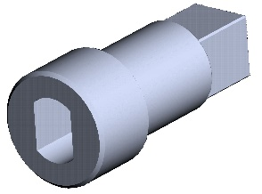
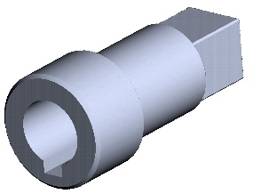
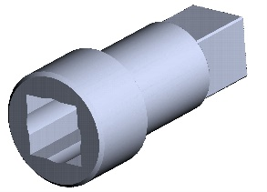

图 3-1双头连接件
Drawing 3-1 Double-end connecting piece

当阀门与执行机构确保连接无误，松开两个90度行程限位螺栓后，方可进行先点动后手动的方式调试，在未提前说明时，执行机构设置输出角度为92°。在调试完毕后，拧紧限位螺栓，并锁紧防松螺母。
In confirmation of correct connection between valve and actuator, loose two bolts of 90 degrees stroke limitation; inching first, and then commissioning manually can be operated. Without prior instructions, output angle of actuator is 92 degrees. After the completion of commissioning, tighten the limit bolt and lock-nut.
对不按规定操作或无机械基础者操作，造成的损，CHEMSUN概不负责。
In case of any damages are in violation of stipulations or by unskillful operators, CHEMSUN does not bear any responsibility.

电气联接/Electric Connection
警告：CHEMSUN公司重要声明：在上电调试之前，一定要确保接地线安全可靠接地，杜绝一切安全隐患。切记！切记！！！
Warning: Important declaration of CHEMSUN : Before electrifying commissioning, please confirm the safe and reliable grounding of grounding wire.

警告：电气连接一定保证在断电状态下进行，连接之前一定要检查电源形式（电压和频率等）和电机参数是否与要求一致。
Warning: The electric connection must be made under power cutoff states; before connection, please inspect the power mode (voltage and frequency) and motor parameters for conformity with the requirements.

警告：电气设备的安装和连接只能由具备相应资质的受过专业培训的电气工程师和他指导并授权的人员完成，严格按照相应规范进行操作。
Warning: The qualified and well-trained electric engineer and authorized personnel are designated for the installation and connection of electric equipment in strict accordance with the codes.

高度集成CPU控制模块/High-integrated CPU Control Module
CHEMSUN G01系列控制模块采用高度集成的CPU 控制技术，在保证功能强大、控制性能稳定、控制精度高的同时，实现了结构紧凑、外形小巧，安装、更换十分方便，为现场维护人员省去很多麻烦。
CHEMSUN G01 series control module adopts high-integrated CPU controlling technology, with qualities of powerful function, stable control property and high control precision, it also features compact structure, tiny appearance, and convenient installation and replacement, so that on-site maintenance personnel can save much trouble.

接线端子排/Wiring Terminal Block
1．CHEMSUN G01型执行机构接线端子仓有两个M12×1.5的进线入口，可根据进线位置自由选择，未用进线端口需保留原堵丝不得松动。
CHEMSUN G01-type actuator terminal warehouse has two M12×1.5 line inlets, free choice can be made according to the position of line inlet; the original blocking wire of unused line port should be retained without loose.
- 按照下面接线端子说明，分别接入电源，给定、反馈信号线，强烈建议信号线采用屏蔽电缆，电源线和信号线分孔进入，以免造成干扰。
- According to the following terminal instructions, respectively connect the power, given and feedback signal wire; strongly recommend that the signal line use shielded cable; power cord and signal wire access into different holes so as to avoid interference.
警告：未接线时，请勿松动接线端子仓堵塞，以防进水，湿气等，非专业人员不得进行从事本接线工作，否则由此造成的后果CHEMSUN概不负责。
Warning: Fasten the plug of the terminal warehouse to avoid water and humidity, etc.; it is forbidden for unprofessional personnel to execute the wiring; otherwise, CHEMSUN does not bear such consequences.

接线端子定义/Definition of Wiring Terminal
表 3-1 调节型接线端子定义
Table 3-1 Definition of Modulating Type Wiring Terminal
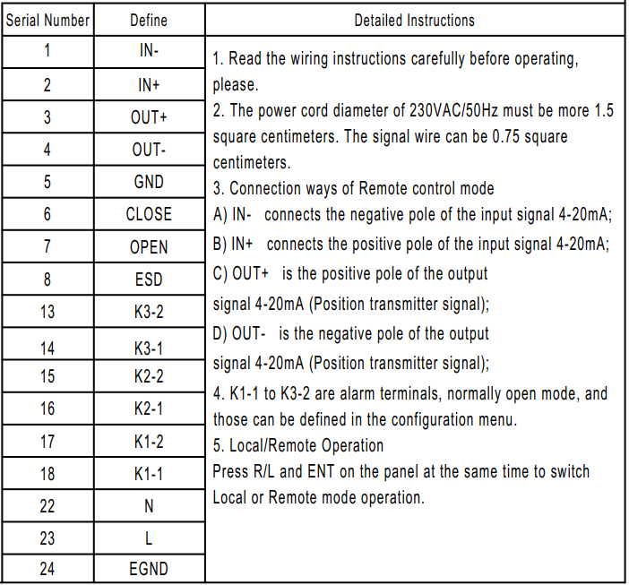
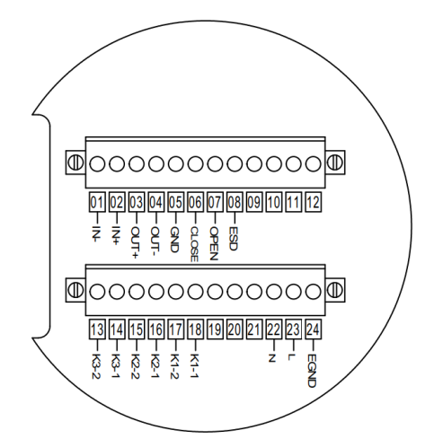

请注意: 此为G01标准供货的接线端子定义。当客户有特殊功能要求，接线端子的个数和
定义可能与上表不同。接线时，务必阅读随机提供的接线图。
Please Note: This is the terminal definition of G01 standard supply. When customers have special functional requirements,the number and difimition of terminals may be different from the above table。Please carefully read the wiring diagram together the supplies.

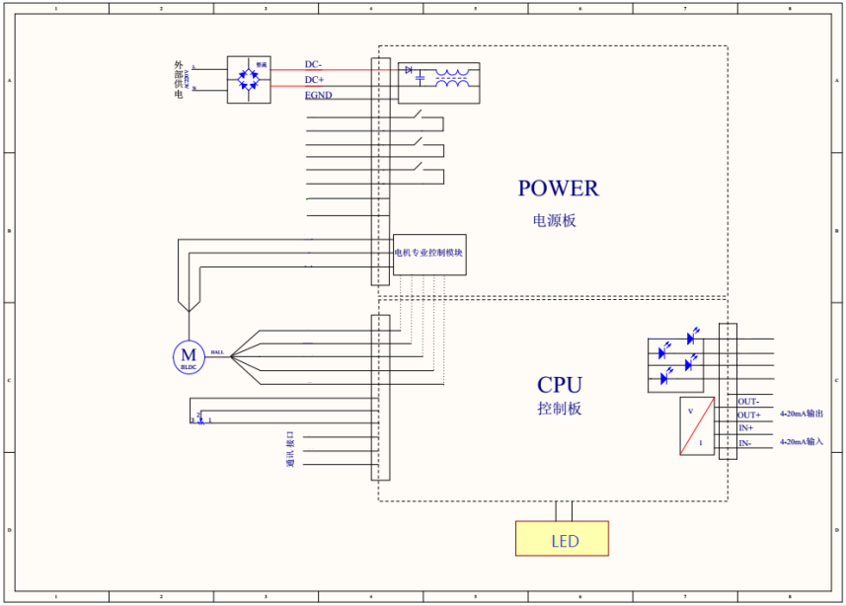
3.6接线原理图/Wiring Schematic Diagram

230VAC调节型/230VAC Modulating Type
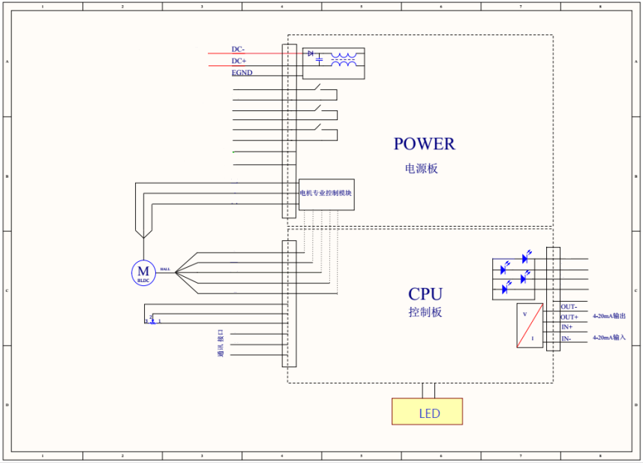

24VDC调节型/24VDC Modulating Type

调试/Commissioning

设置程序简介/Instruction of Setup Procedure

概述/Overview
所有设定功能均存储在执行机构内部的非易失性存储器内，用户可以使用面板组态按钮通过执行机构的液晶显示屏查看所有设定功能，每个功能的设定值均可查看或更改。
All the set functions are saved in NVM of the actuator; the users can use press button in panel to search for all set functions through LCD of actuator; each set function’s value can be searched or changed.
设定程序分为二级：
The set procedure includes two levels:
- 基本设置(Basic_setting):
- 高级设置(Advanced_setting)
警告：所有G01系列执行机构的功能在出厂前均为CHEMSUN 标准默认设定值，除非在订货时有特殊要求，可按要求进行更改，在调试期间如果遇到困难，可以恢复默认设定，返回执行机构出厂的设定，然后开始现场调试。
Warning: Before leaving the factory, all the functions of S-series actuators are set as CHEMSUN standard fault value; special requirements raised in the ordering are strictly adhered; in case of any problem in the commissioning, it is resumed to the default setup status and factory setup of actuator, and then on-site commissioning is started.
警告：默认设定根据需要谨慎使用，因为执行机构出厂后，在现场所设置数据对阀门或者使用厂家来说十分重要。
Warning: The default setup is strictly used according to actual demands; after leaving the factory, the on-site set data of actuator is of vital importance to the valve and user.
警告：必须先进行基本设置。出厂设置在执行机构出厂后，一般不需要改动。
Warning: The basic setup must be finished in advance. After the actuator leaves the factory, the factory setup hardly needs to change.

4.1.2设置程序的基本框图/Basic Block Diagram of Setup Procedure
执行机构设置基本框图

通电开机
设置语言

设定开度
当前开度
状态信息

基本设置
高级设置

手动校准
精度调整
信号故障动作
最大转速
自动手动切换
设置密码
作用方向
报警端口设置
断电故障动作
断电延时
信号校准
PID系数设置
力矩校准
恢复初始设置

图 4-1执行机构设置基本框图

Basic Block Diagram of Setup Procedure

Basic Block Diagram of Setup Procedure

Electricity boot

Select language

CMD
POS
Status information

Advanced Setting
Basic Setting
Settingsetting

Password setting
POSI_NEG effct
Alert com choice
Power failure action
Power failure delay
4~20 mA check
PID parameter setting
Torque calibrate
Restore default setting

Zero menu check
Accuracy adjust
Signal fault action
Maximum speed
Change model

Drawing 4-1Basic Setup Block Diagram of Actuator

4.2进入执行机构的设置程序/Access Setup Procedure of Actuator
执行机构通电开机，出现CHEMSUN Logo后，要进行语言选择，选英文或中文。然后就直接进入自动状态（此为CHEMSUN执行机构在出厂时的默认设置）屏幕显示为：
Once E-actuators electrification, display CHEMSUN Logo, and select language: Chinese or English. Then the actuator is started and directly enters into the “local” status (default setup of CHEMSUN actuator before leaving the factory ). The screen is displayed as follows:
设定： 50.0 %
当前： 50.0 %

R
CMD: 50.0 %
POS: 50.0 %

R

此时显示的屏幕信息为：
The information displayed in the screen is as follows:
第1行—设定信号位置；
1st line -- Position of set point signal;
第2行—执行器当前阀位置；
2nd line -- Current valve position of actuator;
设置程序中按键功能见2.2.1功能按键
The functions of keys in setting procedure is in reference to 2.2.1 Function Button.
在手动状态下，按“ENT”按钮进入设置菜单，设置菜单如下
In local status, press “ENT” button to enter into the setup menu, displayed as follows:
基本设置
初始设置

Basic Setting
Original Setting

此时可通过“OP↑”、“CL↓”按钮改变选择项
Press “OP↑” and “CL↓” button to change the arrow position.

4.3基本设置 (Basic setting)
当光标在基本设置处按“ENT”按钮可进入基本设置项的修改界面。
When the cursor is in the “Basi_Set”, press “ENT” button to enter into the revision interface of the basic setup item.
基本设置项菜单如下：
Menus of basic setup item are as follows:
手动校准
精度调整
信号故障动作
最大转速
自动手动切换
基本设置
ENTTTTTTTTTTTTTT

图4-2 基本设置框图
Basic Setting
Zero Menu Check
Accuracy Adjust
Signal Fault Action
Maximum Speed Setting
Change Model
ENTTTTTTTTTT

Drawing 4-2 Basic setup block diagram

此时屏幕显示如下图：
The screen displays as follows:
Zero Menu Check
Accuracy Adjust
Signal Fault Action
Maximum Speed
Change Model
手动校准
精度调整
信号故障动作
最大转速
自动手动切换

按“ENT”按钮进入参数设置状态，按“CL↓”按钮退出设置，OP↑和CL↓分别为向上和向下选择按钮。设置完成后按“ENT”按钮保存参数。
Press “ENT” button to enter into the setting status of parameters; press “CL↓” button to change the parameters and press “ENT” button for saving it.

4.3.1手动校准. (Zero Menu Check)
手动校准是对阀位全开位置和全关位置的设置，在实际调试过程中，对应的是阀门的允许最大及最小开度位置，进入全开设置时屏幕显示：
In actual commissioning, “Open_pos.” corresponds to the maximum permissible opening position of valve. The screen displays as follows in the open setup:
To Zero
To Span

调整零位
调整量程

设置过程：选择“调整零位”，按“ENT”，屏幕显示如下，按“OP↑”或“CL↓”按钮或摇动手轮使阀门达到全关位置，然后按“ENT”按钮保存

参数（后面的数值为霍尔传感器读数值，取值范围在3000至5000之间）；
选择“调整量程”，按“ENT”，屏幕显示如下，按“OP↑”或“CL↓”按钮或摇动手轮使阀门达到全关位置，然后按“ENT”按钮保存参数（后面的数值为霍尔传感器读数值，取值范围在26000至28000之间）。
调整零位 4000

调整量程 26000

Setting procedure: Press “OP↑” or “CL↓” button or rotate handwheel to move the valve to the open position; press “ENT” button to save parameters(the value in second line refers to potentiometer’s value; the value ranges between 50 to 950; pay attention to the mechanical limit of executing actuator).
警告：调试过程中，在接近阀门的全开或全关位置时，严禁使用点动按钮进行点动操作，否则可能由于位置走过引起阀门或者执行机构的损坏，由于此种原因造成执行机构损坏，CHEMSUN概不负责。
Warning: In the commissioning when open or closed position of the valve is near, it is forbidden to operate by inching button; otherwise, the valve or actuator may be damaged by passing the position. CHEMSUN does not bear maintenance and servicing responsibilities for the damage against actuator by such reasons.

4.3.2精度调整（Accuracy Adjust）
屏幕显示如下：
The screen displays as follows:
输入精度值
100

Input Accuracy
100

此数值在出厂试验时以调整到最优，一般勿需调整。
It is calibrated before leaving the factory, so description thereof will not be repeated.

以下设置过程与以上过程相似，不再过多赘述。
The following setting procedure is similar to that described above, so description thereof will not be repeated.

4.3.3信号故障动作（Signal Fault Action）
“信号故障类型”功能定义为：当执行机构出现给定信号故障时，执行机构所采取的动作。
The functional definition of “Sign_err_type.”: The actions of actuator in case of set signal fault appear in the actuator.
项值解释：
Interpretation of item values:
1. 全开：当发生信号故障时，执行机构运行至全开位置
1.Open_pos. (Open status): In case of signal fault, the actuator operates until open position.
2. 全关：当发生信号故障时，执行机构运行至全关位置
2. Clos_pos. (Closed status): In case of signal fault, the actuator operates until closed position.
3. 保持：当发生信号故障时，执行机构保持当前位置
3. Current1 (Maintenance): In case of signal fault, the actuator maintains in the current position.
4. 指定位置：当发生信号故障时，执行机构运行到预设的位置
4. Set_pos. (Designated position): In case of signal fault, the actuator operates until the preset position.

警告：该项设置的出厂默认值为“保持”，根据实际工艺所需要的阀位由用户自行设定或告知调试服务人员进行现场设置。
Warning: The default value of this item is “Current1 (Maintenance)”; according to the valve position required in actual process,, the user make self-setup or notice the commissioning personnel to make on-site setup.

4.3.4最大转速设置/Maximm Running Speed Setting

按“ENT”键进入此参数设置状态，按“OP↑”或“CL↓”按钮，对当前转速作“增大”或“减小”设置，完成后，按“ENT”按钮保存数据。

Press “ENT”button to enter into this setting status.Then press “OP↑”or “CL↓”button to increase or decrease the parameters,and press “ENT”button for saving it.

4.3.5自动手动设置/Local Manual Control Setup
通过此项设置状自动手动状态（此项与R/L+ENT组合键功能相同）。
Local Manual Control Setup aims to set the Remote/Local status.(It has the same functions with R/L+ENT composite key. )

警告：在执行机构完全调试好之前，此项设置不得选择“自动（远程）”状态，本执行机构在出厂时均设置为“手动（就地）”项。用户根据需要重新设置完参数以后, 一定要将此选项设为“自动（远程）”，通电后直接进入正常运行。
Warning: Before commissioning completion of the actuator, it is forbidden to select “Auto/Automatic (remote)” status for this item. Before leaving the factory, “Manual/Manual (local)” status is set up. The user finishes re-sets up the parameters, it must set up the option into “Auto/Automatic (remote)” status; upon electrification, directly launch out normal operation.

4.4高级设置(Advanced Setting)
当光标在初始设置处按“ENT”按钮可进入高级设置项的修改界面。进入设置界面前需输入密码。初始密码为000000；
When the cursor is in the “Original Setting”, press “ENT” button to enter into
the revision interface of the Advanced Setting item. The initial password is 000000.

设置密码/Password Setting
作用方向/POSI_NEG_Effct
报警端口设置/Alert_com choice
断电故障动作/Power Failure Action
断电延时/Power Failure Delay
PID系数设置/PID Parameter Setting
力矩校准/Torque Calibrate
恢复初始设置/ Restore Default Setting

Advanced Setting
高级设置

ENT

图 4-3高级设置
Drawing 4-3 Advanced Setting

4.4.1设置密码/Password Setting
进入该设置项可以修改初始设置的密码。
Entering this setting you can modify the initial password.

4.4.2作用方向 (POSI_NEG_Effct)
在执行机构安装过程中，可能会遇到阀门的作用方向和执行机构的作用方向不一致，这时候需要对此项设置进行修改。
In the installation of actuator, the effect directions of valve may differ from that of the actuator,; therefore, the setup needs to be revised.
本项设置的默认值为“正作用”。
The default value of this item setup is “Positive (Positive effect)”.
警告：在执行机构调试前，如果发现执行机构与阀门的作用方向不一致，一定要先将此设置调整，再进行基本设置，尤其是“开阀位置”和“关阀位置”的设定。若是因此种原因造成的阀门或执行机构损坏，CHEMSUN概不负责。
Warning: In case of different effect direction between the actuator and valve before commissioning of the actuator, the setup must be adjusted before basic setup, especially “Open_pos.(Valve opening position)” and “Close_pos.(Valve closing position)”. In case of any damage against the valve and actuator due to such reason, CHEMSUN does not bear maintenance and servicing responsibilities.

4.4.3报警端口设置 /Alert_com choice
G01系列有二组报警端口K1-1/K1-2和K2-1/K2-2,可设置为阀位开/关位限位开关。
G01 series have two alert choice,K1-1/K1-2 and K2-1/K2-2,that can be set ON/OFF limit switches.

4.4.4断电故障动作/Power Failure Action
G01系列无此功能选项（此功能只适用于G01系列）。
G01 Series do not have this fuction option（This option only for G01 series）.

4.4.5断电延时/Power Failure Delay
G01系列无此功能选项（此功能只适用于G01系列）。
G01 Series do not have this fuction option（This option only for G01 series）.

4.4.6 PID系数设置/PID Parameter Setting
本选项修改PID参数。
This option is to modify the PID parameter.

4.4.7力矩校准/ Torque Calibrate
该设置为厂家调试人员所用，G01出厂时都已校准，不建议修改。
The factory commmissioning personal are designated for the factory setup.G01 series have been calibrated before delivery from factory,so it is not recommended to change.

4.4.8恢复初始设置/ Restore Default Setting
该设置为厂家调试人员所用，里面设置的参数对于用户以及使用厂家很重要一般不建议修改。
The factory commissioning personnel are designated for the Fact_set(Factory Setup); the parameters in Fact_set are of vital importance to user and manufacturer, so it is not recommended to change.

设备维护和保养/Maintenance and Servicing of Equipment

设备维护周期/ Equipment Maintenance Cycle
在正常使用情况下，CHEMSUN G01系列电动执行机构是免维护的，但是少量的日常维护是必须的。为了确保设备的正常可靠运行，请定期做一次运行测试。
Under normal usage, CHEMSUN G01 series electric actuator is free from maintenance; however, a small amount of daily maintenance is necessary. Please make regular operation test to ensure the normal and reliable operation of the equipment.
当您使用的CHEMSUN 产品出现您解决不了的故障，请您立即与我们办事处、代理商联系，我们将在最短的时间内给您圆满解决问题。
Please contract with our office or agency immediately when you encounter any fault with CHEMSUN products; we promise to settle the problems within the shortest time.

润滑/Lubrication
CHEMSUN G01系列电动执行机构在正常使用条件下，整个寿命周期内无须额外的润滑。所使用的润滑油脂为添加二硫化钼的多用途高级润滑油。如需购买请及时与CHEMSUN中国办事处或各级代理商联系。
Under normal usage, CHEMSUN G01-series electric actuator does not require additional lubrication in the whole life cycle. The lubricant refers to multi-purpose senior lubricant containing molybdenum disulfide. Please contact with CHEMSUN Chinese office or agent at various levels for procurement.

故障信息及处理一览表/List of Fault Information and Settlement
故障情况  Faults | 可能故障原因  Possible Reasons | 故障处理  Solutions
不能开机（LCD不显示）  It can not be started ( LCD does not display). | 无供电电源或电源不符合要求  There is no power supply or the power fails to meet the requirements. | 检查电源和接线端子接线的正确性和可靠性。  Inspect the power supply and wiring terminal for correct and reliable wiring.
 | 控制电路保险丝熔断或回路开路  Fuse of control circuit is fused or loop is open. | 检查电路或更换保险  Inspect the circuit or replace the fuse.
开机后，给定指令，执行机构不动作  Upon start and issuing command, the actuator has no operation. | “全开位置”和“全关位置”数据相等  “Open_Pos/Open position” and “Close_Pos”/Closed position” are equivalent. | 进入设置菜单检查数据，并修改。  Enter into the setting menu, inspect and revise the related data.
 | 电机绕组烧毁  The motor winding is burnt out. | 更换电机或维修  Replace or repair the motor.
 | 电机超温保护  The motor suffers from over temperature protection. | 电机降温  Cool down the motor.
 | 开限位、关限位  Limit switches in open/close direction. | 反向运转后正常  Operate reversely and become normal.
 | 开向过力矩、关向过力矩  Over torque in valve opening/closing direction. | 反转接触过力矩  Rotate reversely and contract with the excess torque.
手动操作时执行机构不动作或很难动作  In the manual operation, the actuator has no operation or suffers from operation difficulty. | 传动轴承卡涩  The transmission shaft is blocked. | 维修或更换  Repair or replace
 | 阀杆和执行机构输出轴不同轴  Valve stem and actuator’s output shaft are not co-axial. | 维修或更换  Repair or replace
 | 阀门卡涩或损坏  The valve is blocked or damaged. | 维修或更换  Repair or replace
 | 传动齿轮没有润滑  The transmission gear isn’t lubricated. | 进行加油润滑  Add lubricant
电机工作时，阀门不动作  In the normal operation of motor, the valve has no operation. | 传动齿轮脱离或损坏  The transmission gear is stripped or damaged. | 维修或更换  Repair or replace
 | 电机轴承损坏或卡涩  The motor shaft is blocked or damaged. | 维修或更换  Repair or replace
 | 阀门卡涩或损坏  The valve is blocked or damaged. | 维修或更换  Repair or replace
 | 阀门轴、阀杆的驱动螺母损坏  The driving nut of valve shaft and valve stem is damaged. | 维修或更换  Repair or replace

本操作手册由北京凯姆斯智控科技有限公司摘录和译制，最终解释权归我公司所有。如有问题请及时与我们联系，如有改动恕不另行通知！
The operation manual is extracted and translated by Beijing CHEMSUN intelligent controls Co. Ltd., and the final interpretation right belongs to us. Please contact us whenever you encounter any problem; we reserves the right to change the above statement without prior notice!

CHEMSUN EUROPE GMBH 北京凯姆斯智控科技有限公司
Add: C/O Globe Office Center 地址：北京市大兴区团河路9号团河行宫别墅第19栋 Bettinastr.30,60325 Frankfurt / Main 电话：+（86）10 61277625
Fon: +49(0) 69 1338 5311 Fax: +49(0) 69 1338 5312 传真：+（86）10 87582920
URL: www.chemsun.de 网址：www.chemsun.com
Email: sales@chemsun.de 邮箱：sales@chemsun.com

